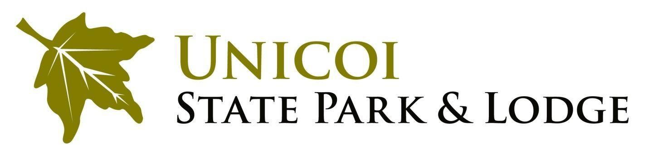

The 44th Fireside Arts and Crafts Show will be held February 16th and 17th, 2019.
Unicoi State Park and Lodge is excited about the show and is certain it will be a tremendous success once again. This show will be coordinated by t he Unicoi State Park Programming Department. As a change to previous years the show will be opened to a larger variety of artistic mediums.

The cost for new participating artists is $150.00 per booth for those who book between 6/1/2018 and 10/31/18. If booking between 11/1/18 and 12/31/2018 the cost per booth will $175.00. The price for 2 booth spaces is $300. The booth fee will not include lunch, but lunch will be offered for an additional fee on both Saturday and Sunday.

All vendors are encouraged to demonstrate their work during the duration of the show. There is no cost for the public and there will be 3 different locations for the show- Unicoi State Park and Lodge, The Helen Arts and Heritage Center and the Sautee Nacoochee Cultural Center.

A special lodging room block will be set aside for all vendors at $79.00 per night plus tax and $10 lodge fee for those booking 6/1-9/30/18 and $89 for those booking 10/1-12/1/18.
.
The approximate booth sizes are 10’X10’. We will do our best to meet your requests. If your booth requires two booth spaces, then you must purchase two spaces, two spaces maximum. Unicoi does not provide extension cords or power strips. We do provide tables and chairs upon request (please indicate on your application). Although it is an indoor show, lighting throughout the building varies and is not always conducive to the needs of the vendors. Please indicate if you need electricity on your application, as well as any other special requests (floor preference, near the loading dock, next to a friend’s booth, etc.) If you require the use of a tent or canopy, please indicate this on your application, as some spaces are not conducive to tents or canopies.

Applicants may request the 2019 application by emailing Maranda Stone at m.stone@unicoilodge.com or calling 706-878-4727. The 2019 application may also be found at www.unicoilodge.com under the “Things to Do” tab.

GENERAL INFORMATION

The 2019 show will take place on February 16th and 17th from 10am-6pm Saturday and 10am till 4pm Sunday.
UNICOI FIRESIDE CRAFT/ART SHOW RULES AND REGULATIONS
In fairness to all artist/crafters that are accepted into the Fireside Craft/Art Show and to insure a quality show for our visitors, we require that all participants comply with the following rules. All show rules will be enforced. Failure to abide by these rules can result in non-acceptance in future years.
- Craft or Art work must be the direct product of artist. Items created from kits will not be considered. kits or how-to products will not be permitted for sale.
- Only one (1) craft/art category will be allowed per booth. If each individual handmade product is created through efforts of more than one artist or crafts person this is acceptable.
- Original art must occupy at least 50% of the booth display. The remainder 50% of the booth must also be the direct product of the applicant. Medium not included in the application will not be permitted.
- Applicants taking advantage of the special participant rates MUST pay full booth fee to Unicoi State Park at the time that the application is submitted. Applicants must provide own Booth/Display. Booth fee is non-refundable.
- Booths are required to be completely set up and ready to open by Saturday at 9:30 am on Saturday, Feb. 16th.
- Booths must remain set up until 4pm Sunday Feb. 17. There must be enough products to sell through the entire show.
- Application forms must be signed to complete registration.
- Artists/Crafters need to remain in their booths Saturday 10am till 6pm and Sunday from 10am to
4pm except for breaks and/or emergencies.
- We will have a “Best of Show” booth competition and announce the winner on Sunday evening. A confidential jury will vote on overall booth presentation, and not on the quality of artwork or craftsmanship. Prizes will be awarded for the top three booths. First place booth will receive a voucher for a free booth for next year’s show.
- This year Fireside will be accepting food vendors that are unique to the area and have unique products.

Booth Application: Fireside Arts and Crafts Show- February 16th and 17th , 2019

Name_ Telephone #_
E-mail
Address _City State/Zip_
Name of Business if applicable: ______________________________________________

Type of Medium: _____________

Please assist us in our promotions by giving us a more detailed description of your craft or art.

Price Range Arts or Craft? $ to $_ Demonstrating at the Show? YES _NO

Require Electricity? YES NO

*Note that electrical cords and additional lighting will not be provided

Requirements: # Chairs_

# Tables *Tablecloths will not be provided.

I will need_____ name tags for _____________________________________________________________
*Note, the nametag ensures access to the exhibit area when the show is closed.

If I am selected as an exhibitor for the Unicoi Fireside Craft/Art Show, I agree to abide by the rules and regulations governing the show as shown on the previous page.

APPLICATION DEADLINE: December 31, 2018.

Mail Application and Booth Fee check to:
Unicoi State Park and Lodge

Attn: Maranda Stone

1788 Hwy 356
Helen, GA 30545

*****************************************************************************************

UNICOI FIRESIDE CRAFT/ART SHOW LIABILITY RELEASE FORM

Exhibitors shall be solely responsible for operating facilities in a safe and proper manner. Unicoi State Park & Lodge shall have no duties or responsibilities for operating, or supervision of said facilities.
Exhibitor shall and does hereby agree to occupy, use and enjoy the leased premises at its sole risk shall pay, protect, indemnify, release, save, and hold Unicoi State Park & Lodge and its employees and agents harmless from and against all liabilities, damages, cost, expenses (including all attorney’s fees and expenses incurred by Unicoi State Park & Lodge and any of the Unicoi State Park & Lodge employees or agents), causes of action, suits, demands, judgments and claims of any nature whatsoever (excluding those based upon the negligence of the Unicoi State Park & Lodge, but not including those caused in whole or part by the negligence of the Exhibitor, its officers, agents, employees, customers, invites or licensees), arising from, by reason of or in connection with: (I) injury or death of persons or damage of property (a) on the premises or
(b) in any manner arising from use, non-use or occupancy of the Exhibitors officers, agents, employees, customers, invites, or licensees or © resulting from a condition of the premises, excluding any conditions of the premises for which Unicoi State Park & Lodge specifically is responsible under the Agreement, if any:
(ii) violation of any agreement, representation, warranty, provision, term of condition of this Agreement by Exhibitor of any of Exhibitor’s officers, agents, or employees: or (iii) violation of any law affecting the premises or the occupancy or use of the premises.

SIGNATURE:

DATE: _ __________________________

