Group Programs
Unicoi State Park and Lodge

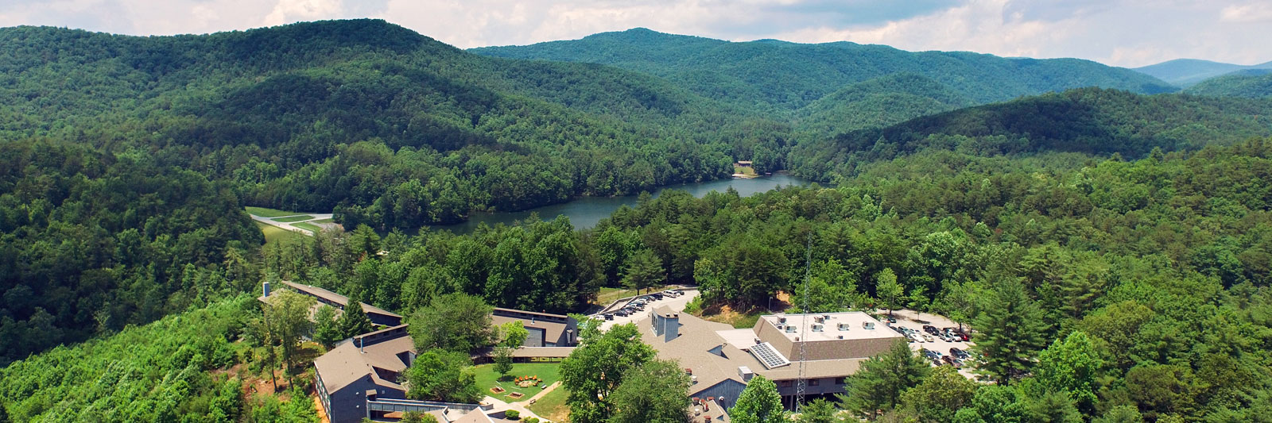

How to Plan a Group Program
The first step in planning for a group program would be to explore our list of program topics below. Select a program that is appropriate for your group’s size, age range, and time availability. Have questions or special requests? Contact us! We are extremely flexible when planning and coordinating, and we can work with you to design a program that is designed to suit your needs.

Scheduling Your Trip
To schedule a group program, contact our Activities Manager, Karen Lovan, at 706-878-2201 EXT. 592. Or email us at activities@unicoilodge.com. When contacting us, please be prepared with the following information:
- Group name or school
- Person of contact (name, email, phone number)
- Number of attendants
- Age/grade level of the students or group
- Program topic
- Preferred and alternate dates of program
- Time of arrival and desired length of program
- Tax exemption status
- Any special considerations (handicap accessible, hearing/vision needs, etc.)

Field Trips
Our field trip programs are designed for elementary age students from kindergarten through fifth grade. If there is a specific lesson not listed here, we can work together to develop a lesson that will give your students the experience you desire. Most of the lessons include a guided hike, as well as time in our playground area. If you would to book a picnic pavilion for lunch, please include this request at time of booking. Pricing varies depending on type of program.
- Rocks and Minerals
- Mammals, Animal Habitats, Food Chain
- Tree ID
- Pioneers and Early Settlers
- Creek and Cherokee Indians
- Owl Pellet Lab
- Trout Release
- Snakes/Reptiles
- Scavenger Hunt with GPS
- Lake Ecology
- Birds of Prey

Outdoor Programs and Activities
Our outdoor programs can be modified to fit your group’s needs and wishes. Pricing varies depending on type of activity.
- Campfire, stories and S’mores
- Full beach rental (only mornings)
- GPS Scavenger Hunt
- Guided Nature Hike
- Archery
- Fly Fishing School
- Kayak/paddle board rental
- Slack lining

Team Building Activities
Our team building activities are great for all types of businesses, family reunions, and any other group of individuals looking to grow closer and become more cohesive. The games and activities are designed to be fun and motivational, while also encouraging communication, planning, problem solving, and conflict resolution. All of our activities incorporate decision-making, leadership, teamwork, trust, creative thinking and following directions.
- 10-200 participants
- Minimum of 10
- $15 plus tax per participant

Program Guidelines

- Program fees vary based on program desired, amount of materials needed, length of program and number of participants.

- A deposit of half the total amount is required for all group activities.

- A minimum of 10 participants is required.

- A cancellation notice of at least 14 days in advance is required. If a cancellation occurs within 14 days, deposit will be forfeited. Program substitutions can be made due to bad weather or other circumstances beyond both parties control.

- Please plan to arrive at least 30 minutes prior to the scheduled program start time.

- In order to maintain a safe and educational environment, it is up to the teachers, chaperones and adults associated with the group to monitor and maintain the order of the group throughout the duration of the program.

